**Building on a Firm Foundation: Supporting Students with   
More** Intensive Support Needs   
in UDL Environments

By Joy Smiley Zabala, Ed.D.

Published: July 29, 2016

The content of this document was developed under a cooperative agreement with the U.S. Department of Education, #H327Z140001. However, this content does not necessarily represent the policy of the U.S. Department of Education and you should not assume endorsement by the Federal Government. Project Officer: Michael Slade, Ed.D.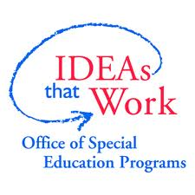

This work is licensed under a [Creative Commons Attribution-ShareAlike 4.0 International](http://creativecommons.org/licenses/by-sa/4.0/) license. http://creativecommons.org/licenses/by-sa/4.0/

Creative Commons logo: Attribution-ShareAlike

National Center on Accessible Educational Materials (2015). *Building on a Firm Foundation: Supporting Students with More Intensive Support Needs in UDL Environments*. Wakefield, MA: National Center on Accessible Educational Materials. Retrieved [insert date] from http://aem.cast.org/about/publications/2016/supporting-students-intensive-support-udl.html

# Abstract

Universal Design for Learning is the firm foundation for the education all students. Some students with more intensive support needs also require individualized services based on their unique needs in order to participate in and benefit from learning environments built and maintained according to the principles and practices of UDL. A student scenario is used to illustrate the complementary nature of UDL and individualized supports and services.

# Introduction

Over the years, the positioning of Universal Design for Learning (UDL) has moved from a technology approach to increasing the participation and achievement of students in the margins to a deeply curricular approach for lowering barriers to participation and achievement for all learners. Given this shift, there has been some discussion in the field about the term “universal” and questioning of whether when discussing UDL if all really means all. This discussion is sometimes couched in the misunderstanding that UDL for all and individualized services for some are mutually exclusive. This is further complicated by the erroneous notions like “UDL only applies to general education environments” or “that if teachers “do” UDL right, specially designed instruction and supports such as assistive technology and accessible materials will no longer be needed.” This paper presents an overview of UDL and discusses specialized services and supports through the lens of an individual student. Anna Maria’s story is an illustration of the notion that UDL and specialized supports and services are complementary supports that enable all learners to experience the benefits and improved outcomes of education that is designed, delivered and evaluated according to the principles and practices of UDL.

# UDL Basics

Universal design for learning (UDL) is a framework to improveand optimize teaching and learning for all people based on scientific insights into how humans learn. UDL call for proactively designing learning experiences – from the beginning – that enable all learners to gain knowledge, skills, and enthusiasm for learning needed to be expert, lifelong learners. UDL thinking does not assume that all learners are the same or that their outcomes will be the same, but rather that variability exists both across learners and within individual learners. In other words, that within any group of learners there will be individuals who excel and individuals who struggle. Further, that within each individual there are areas in which the individual excels and areas in which the individual struggles.

Given the assumption of variability, core UDL principles call for proactive planning to ensure that:

* Firm goals are established for all learners
* High expectations for the achievement of all learners are maintained
* Unnecessary barriers to learning are identified and lowered to the greatest extent possible
* Appropriate learning supports and accommodations, are available when and where needed

Figure 1 illustrates the importance of understanding and considering variability, not only across and within students, but also within the learning environments in which students are expected to learn and grow. Also consider variability within the tools that they need to use to do the tasks that lead to reach high expectations, master goals and improve educational outcomes. When educators think through what barriers to learning might exist in the goals, methods, materials and assessments, they are able to consider how those barriers can be lowered so that all learners have the opportunity to participate actively and reach high expectations.

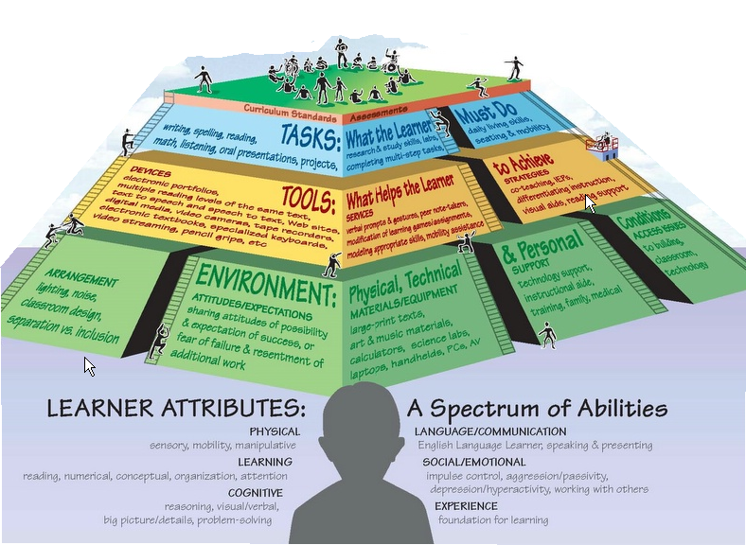

Figure 1. Learning Supports Pyramid

# Beyond the Basics: Anna Maria’s Story

Intensive support needs may not always be “visible.”

Figure 2, taken from a presentation by Dr. Todd Rose, demonstrates how variability might exist within a single student–we will call her Anna Maria–to underscore the importance of understanding variability and disability so that areas of challenge are supported and areas of strength can be recognized and built upon.

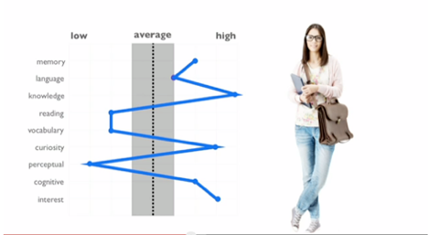

Figure 2. Myth of the Average (Todd Rose)

While Anna Maria has considerable strengths in knowledge, curiosity, cognitive and interest, unless her challenges in reading, vocabulary and perception are supported, it is unlikely that her strengths will be widely and immediately recognized. District-wide policies and planning based on the principles and practices of UDL have lowered most barriers for her but she needs additional supports to participate and achieve at grade level.

## Specially Designed Instruction

Anna Maria has made marked improvement in reading over the last six months, moving from reading independently at the primer level to 4th grade level. This is excellent and effective instruction needs to be continued. Although the instruction she needs is used for all students at the elementary level, it is specially designed for Anna Maria because it is not taught to all students at the middle school she attends.

## Accessible Educational Materials

Reading instruction is benefitting Anna Maria; however, as an 8th grader, she needs access to grade level materials used across the curriculum. Whether the materials are print or digital, it is clear that her current independent reading level does not provide her with access to grade level materials indicating a clear need for timely acquisition of accessible educational materials. Data indicate that she benefits from Audio Supported Reading (ASR), a technology based technique that enables her to both see and hear the information at the same time. Fortunately, UDL has led to a district policy requiring that all digital materials meet rigorous accessibility standards, thus the option to provide synchronized visual and auditory output is available to all students, including Anna Maria. Printed materials must be retrofitted to the digital text format for Anna Maria so that she can use ASR for those materials as well. While this solution is not necessary for every student, it lowers barriers for Anna Maria.

## Accessible and Assistive Technology

In Anna Maria’s district, attention to the principles of UDL extended to technology. As with materials, district policy requires that all technologies include robust options that broaden usability for most students and have interoperability with a wide variety of assistive technologies that are needed by some students. For Anna Maria, the technologies used by others also work for her. When materials are digital, she can independently turn on the options she needs whenever she needs them. When learning materials are acquired in an accessible digital format, she uses a tablet that has the capability of proving the ASR that she needs. The tablet, which she requires for reading, is, for her, assistive technology even though the same technology is commonly used by other students.

# Conclusion

Through Anna Maria’s story we are able to see that, for some students, additional supports needed are minimal IF the principles and practices of UDL are used to support systemic change at the policy and guidelines level. The fact that proactive design for all students led to the inclusion of rigorous accessibility standards for acquisition of materials and technologies used by all, made a huge difference in the additional supports and services needed to meet Anna Maria’s individual needs. When student have more visible needs such as low vision, blindness, hearing loss, physical, intellectual or behavioral challenges, the specialized instruction and additional supports needed will be greater and more varied. However, when additional supports and services are needed, the starting place is much further along the pathway to success than it would be with-out the firm foundation of UDL.

# Resources

For more information and many resources on accessible educational materials (AEM) and accessible technologies, visit the website of the [National Center on Accessible Educational Materials for Learning](http://aem.cast.org/).

# References

Jackson, R. (no date) Audio Supported Reading in Action: New Tools, Increased Proficiency. Video retrieved from http://aem.cast.org/navigating/audio-supported-reading.html

Jackson, R. and Karger J. (2015) Audio Supported Reading and Students with Learning Disabilities. Retrieved from http://aem.cast.org/about/publications/2015/audio-supported-reading-learning-disabilities-asr-ld.html

Rose, T. (2013, June 19). The Myth of the Average: Todd Rose at TEDXSonomaCounty. Video retrieved from https://www.youtube.com/watch?v=4eBmyttcfU4